

REPUBLIC OF TÜRKİYE
UNIVERSITY OF YALOVA
INSTITUTE OF GRADUATE STUDIES

DEPARTMENT OF…………………
…………………PROGRAM

THESIS TITLE

MASTER’S THESIS/PH.D. THESIS/PROJECT

FIRST and LAST NAME of AUTHOR

SUPERVISOR: TITLE and FIRST and LAST NAME of SUPERVISOR
(If available) CO-SUPERVISOR: TITLE and FIRST and LAST NAME of CO- SUPERVISOR

YALOVA
MONTH YEAR

REPUBLIC OF TÜRKİYE
UNIVERSITY OF YALOVA
INSTITUTE OF GRADUATE STUDIES

DEPARTMENT OF…………………
…………………PROGRAM

THESIS TITLE

MASTER’S THESIS/PH.D. THESIS/PROJECT

FIRST and LAST NAME of AUTHOR
STUDENT NUMBER

SUPERVISOR: TITLE and FIRST and LAST NAME of SUPERVISOR
(If available) CO-SUPERVISOR: TITLE and FIRST and LAST NAME of CO- SUPERVISOR

YALOVA
MONTH YEAR

T.C.
YALOVA ÜNİVERSİTESİ
LİSANSÜSTÜ EĞİTİM ENSTİTÜSÜ

………………… ANABİLİM/ANASANAT DALI
………………… BİLİM DALI

TEZ BAŞLIĞI

YÜKSEK LİSANS TEZİ / DOKTORA TEZİ / PROJE

ADI SOYADI
ÖĞRENCİ NUMARASI

DANIŞMAN: UNVANI ADI SOYADI
(Varsa) ORTAK DANIŞMAN: UNVANI ADI SOYADI

YALOVA
AY YIL
Yalova Üniversitesi Lisansüstü Eğitim Enstitüsü’nün ……Öğrenci No........ numaralı Yüksek Lisans/Doktora öğrencisi …........ADI SOYADI......., ilgili yönetmeliklerin belirlediği gerekli tüm şartları yerine getirdikten sonra hazırladığı “……………………..……TEZ BAŞLIĞI.........................................................................………………………” başlıklı tezini aşağıda imzaları olan jüri önünde sunmuş ve başarılı bulunmuştur.

İmza / Kanaati
(Kabul/Ret)

Prof. Dr. Adı SOYADI …………..……… / …………...………
Danışman, Yalova Üniversitesi

Doç. Dr. Adı SOYADI ………….….…… / ……….……..……
Jüri Üyesi, …….….. Üniversitesi

Doç. Dr. Adı SOYADI ……….…….…… /…. …………..……
Jüri Üyesi, …….….. Üniversitesi

Dr. Öğr. Üyesi Adı SOYADI ……….…….…… / …….………..……
Jüri Üyesi, …….….. Üniversitesi

Dr. Öğr. Üyesi Adı SOYADI …….……….…… / ……………...……
Jüri Üyesi, ………... Üniversitesi

Tez Savunma Tarihi: 01.11.2025

ETHICAL DECLARATION
In this thesis entitled ‘…………………………’, prepared in accordance with the Thesis/Project Writing Rules of the Institute of Graduate Studies of Yalova University, I declare that I have obtained the data, information and documents presented in the thesis within the framework of academic and ethical rules, that I have presented all information, documents, evaluations, and results in accordance with scientific ethical and moral standards, that I have properly cited all works used in this thesis, that I have not altered any of the data used, and that the work presented in this thesis is original. I hereby declare and undertake to accept any legal liability that may arise if the contrary is found to be true.

Signature
First and LAST NAME

ETİK BEYAN
Yalova Üniversitesi Lisansüstü Eğitim Enstitüsü Tez/Proje Yazım Kuralları’na uygun olarak hazırladığım “………………………….” başlıklı bu tez çalışmasında; tez içinde sunduğum verileri, bilgileri ve dokümanları akademik ve etik kurallar çerçevesinde elde ettiğimi, tüm bilgi, belge, değerlendirme ve sonuçları bilimsel etik ve ahlak kurallarına uygun olarak sunduğumu, tez çalışmasında yararlandığım eserlerin tümüne uygun atıfta bulunarak kaynak gösterdiğimi, kullanılan verilerde herhangi bir değişiklik yapmadığımı, bu tezde sunduğum çalışmanın özgün olduğunu bildirir, aksinin tespiti halinde doğabilecek her türlü hukuki sorumluluğu kabul ettiğimi taahhüt ve beyan ederim.

İmza
Ad SOYAD

FOREWORD
I would like to thank my supervisor, ……..………, who never withheld his assistance during my master's education, always supported me academically, and guided me on the right path. I would like to thank my family for always being by my side and never withholding their support. (This paragraph is provided as an example. Different expressions may also be used.)
I would like to thank the Scientific Research Projects (BAP) Coordination Unit of Yalova University (Project No: 2021/BAP/001) for enabling this thesis work to be supported. (This sentence is provided as an example. This expression or a different expression with a similar meaning may be used.)
Month – Year First and LAST NAME

TABLES OF CONTENTS
ETHICAL DECLARATION …………………………………………………………………...i
FOREWORD …………………………………………………………………………………..ii
TABLES OF CONTENTS ……………………………………………………………………iii
LIST OF SYMBOLS AND ABBREVIATIONS………………………………………… iv
LIST OF TABLES v
LIST OF FIGURES vi
ABSTRACT vii
ÖZET viii
1. INTRODUCTION 1

1.1. Table of Contents Page 2

1.2. List of Tables and List of Figures Pages 2
2. FIRST LEVEL HEADING 3

2.1. Second Level Heading 3

2.1.1. Third level heading 4
3. FIRST LEVEL HEADING 7

3.1. Second Level Heading 7

3.1.1. Third level heading 7
4. CONCLUSIONS AND RECOMMENDATIONS 9
REFERENCES 11
CURRICULUM VITAE 13

LIST OF SYMBOLS AND ABBREVIATIONS
SYMBOLS
E : Energy
µ : Learning coefficient
α : Triggering angle
V : Solution volume (ml)
ABBREVIATIONS
DSİ : Devlet Su İşleri
HGK : Hukuk Genel Kurulu
İİBK : İş ve İşçi Bulma Kurumu
NaCI : Sodium Chloride
OECD : Organisation for Economic Co-operation and Development
TCK : Türk Ceza Kanunu
TSE : Türk Standartları Enstitüsü
TBMM : Türkiye Büyük Millet Meclisi
YÖK : Yüksek Öğretim Kurulu

LIST OF TABLES
Tables 2.1. Table description 4

LIST OF FIGURES
Figure 1.1. Opening the styles screen 1
Figure 1.2. Styles screen 1
Figure 1.3. Updating the table of contents page 2

TITLE OF THESIS

ABSTRACT
The title of the thesis should be centered on the page, in bold and capital letters. The abstract should not exceed one page. Briefly, the purpose of the research, main conclusions, and comments should be included. “1” line spacing should be used in the abstract, the space before the space should be “0 pt”, and the next space should be “6 pt”.
A maximum of 5 keywords should be used and the keywords should be written with the first letter of each word capitalized. Keywords should be separated by commas.
Keywords: Keyword 1, Keyword 2, Keyword 3

TEZ BAŞLIĞI

ÖZET
Tez başlığı sayfada ortalı, kalın ve büyük harflerle yazılmalıdır. Özet, bir sayfayı geçmeyecek şekilde yazılmalıdır. Kısaca, araştırmanın amacı, başlıca sonuç ve yorumlar yer almalıdır. Özet yazımında “1 (TEK)” satır aralığı kullanılmalı, aralıktan önceki boşluk “0 nk”, sonraki boşluk “6 nk” olarak belirlenmelidir.
En fazla 5 anahtar kelime kullanılmalı ve anahtar kelimeler her kelimenin ilk harfi büyük olacak şekilde yazılmalıdır. Anahtar kelimeler virgül ile ayrılmalıdır.
Anahtar Kelimeler: Anahtar kelime1, Anahtar kelime 2, Anahtar kelime 3

1. INTRODUCTION
This template has been prepared in accordance with the rules outlined in the thesis writing guide for master's theses, doctoral theses, and non-thesis master's projects in the departments affiliated with the Institute of Graduate Studies of Yalova University, with the aim of assisting in thesis/project writing. Please review the Thesis Writing Guide before using this template.
In this template, styles have been created for headings, figure and table captions in accordance with the thesis writing guide. Figure 1.1 shows how to access the styles screen.
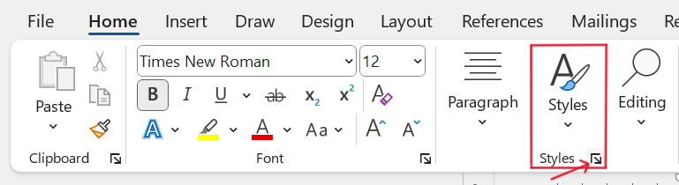
Figure 1.1. Opening the styles screen
After the styles screen opens, you will see a screen with defined styles as shown in Figure 1.2.
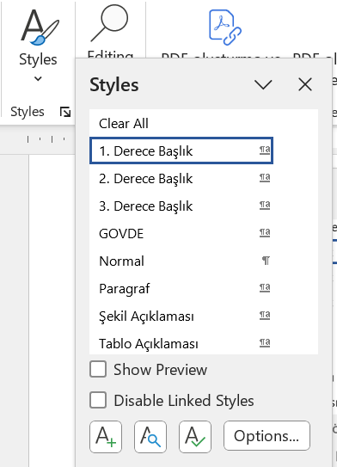
Figure 1.2. Styles screen
Figure 1.2 shows the styles defined for the thesis writing guide. The template defines the following styles: First-level heading, Second-level heading, Third-level heading, Paragraph, Figure, Figure caption, Table caption. The Third-level heading style should be used for headings below the third level. In the thesis document, after selecting any heading with the mouse, the style of that heading can be defined by clicking on the relevant style. For example, when the figure caption below the figure is selected and the ‘Figure Caption’ style is chosen, the necessary definitions for the figure caption (such as the required spacing before and after, centring on the page, etc.) will be automatically loaded.

1.1. Table of Contents Page
The ‘Table of Contents’ page provided in the template has been created automatically. After creating the thesis headings using the template, the ‘Table of Contents’ page can be updated according to the final state of the thesis by right-clicking on the ‘Table of Contents’ page and selecting the ‘Update Field’ option from the menu that opens. Figure 1.3 shows how to update the Table of Contents page.
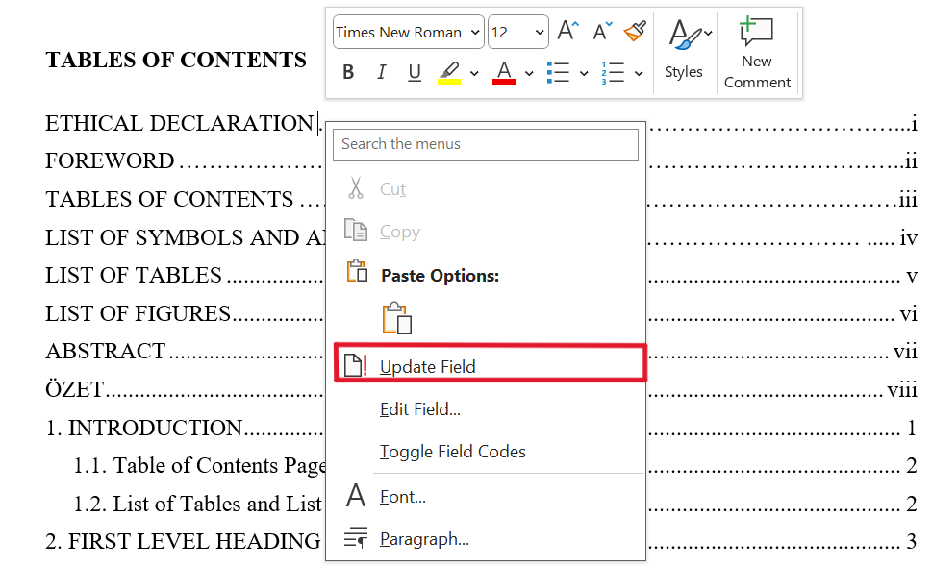
Figure 1.3. Updating the table of contents page

1.2. List of Tables and List of Figures Pages
The ‘List of Tables’ and ‘List of Figures’ pages provided in the template are also automatically generated, just like the ‘Table of Contents’ page. By using the template, the same procedures described in section 1.1 for the ‘Table of Contents’ page can be applied to the ‘List of Tables’ and ‘List of Figures’ pages to create the necessary lists of tables and figures appropriate for the thesis.

2. FIRST LEVEL HEADING
Lorem ipsum dolor sit amet, consetetur sadipscing elitr, sed diam nonumy eirmod tempor invidunt ut labore et dolore magna aliquyam erat, sed diam voluptua. At vero eos et accusam et justo duo dolores et ea rebum. Stet clita kasd gub rgren, no sea takimata sanctus est Lorem ipsum dolor sit amet, consetetur sadipscing elitr, sed diam nonumy eirmod tempor invidunt ut lab ore sit et dolore magna.
Lorem ipsum dolor sit amet, consetetur sadipscing elitr, sed diam nonumy eirmod tempor invidunt ut labore et dolore magna aliquyam erat, sed diam voluptua. At vero eos et accusam et justo duo dolores et ea rebum. Stet clita kasd gub rgren, no sea takimata sanctus est Lorem ipsum dolor sit amet, consetetur sadipscing elitr, sed diam nonumy eirmod tempor invidunt ut lab ore sit et dolore magna.
Lorem ipsum dolor sit amet, consetetur sadipscing elitr, sed diam nonumy eirmod tempor invidunt ut labore et dolore magna aliquyam erat, sed diam voluptua. At vero eos et accusam et justo duo dolores et ea rebum. Stet clita kasd gub rgren, no sea takimata sanctus est Lorem ipsum dolor sit amet, consetetur sadipscing elitr, sed diam nonumy eirmod tempor invidunt ut lab ore sit et dolore magna.
Lorem ipsum dolor sit amet, consetetur sadipscing elitr, sed diam nonumy eirmod tempor invidunt ut labore et dolore magna aliquyam erat, sed diam voluptua. At vero eos et accusam et justo duo dolores et ea rebum. Stet clita kasd gub rgren, no sea takimata sanctus est Lorem ipsum dolor sit amet, consetetur sadipscing elitr, sed diam nonumy eirmod tempor invidunt ut lab ore sit et dolore magna.

2.1. Second Level Heading
Lorem ipsum dolor sit amet, consetetur sadipscing elitr, sed diam nonumy eirmod tempor invidunt ut labore et dolore magna aliquyam erat, sed diam voluptua. At vero eos et accusam et justo duo dolores et ea rebum. Stet clita kasd gub rgren, no sea takimata sanctus est Lorem ipsum dolor sit amet, consetetur sadipscing elitr, sed diam nonumy eirmod tempor invidunt ut lab ore sit et dolore magna.
Lorem ipsum dolor sit amet, consetetur sadipscing elitr, sed diam nonumy eirmod tempor invidunt ut labore et dolore magna aliquyam erat, sed diam voluptua. At vero eos et accusam et justo duo dolores et ea rebum. Stet clita kasd gub rgren, no sea takimata sanctus est Lorem ipsum dolor sit amet, consetetur sadipscing elitr, sed diam nonumy eirmod tempor invidunt ut lab ore sit et dolore magna.
Lorem ipsum dolor sit amet, consetetur sadipscing elitr, sed diam nonumy eirmod tempor invidunt ut labore et dolore magna aliquyam erat, sed diam voluptua. At vero eos et accusam et justo duo dolores et ea rebum. Stet clita kasd gub rgren, no sea takimata sanctus est Lorem ipsum dolor sit amet, consetetur sadipscing elitr, sed diam nonumy eirmod tempor invidunt ut lab ore sit et dolore magna.

2.1.1. Third level heading
Lorem ipsum dolor sit amet, consetetur sadipscing elitr, sed diam nonumy eirmod tempor invidunt ut labore et dolore magna aliquyam erat, sed diam voluptua. At vero eos et accusam et justo duo dolores et ea rebum. Stet clita kasd gub rgren, no sea takimata sanctus est Lorem ipsum dolor sit amet, consetetur sadipscing elitr, sed diam nonumy eirmod tempor invidunt ut lab ore sit et dolore magna.
Lorem ipsum dolor sit amet, consetetur sadipscing elitr, sed diam nonumy eirmod tempor invidunt ut labore et dolore magna aliquyam erat, sed diam voluptua. At vero eos et accusam et justo duo dolores et ea rebum. Stet clita kasd gub rgren, no sea takimata sanctus est Lorem ipsum dolor sit amet, consetetur sadipscing elitr, sed diam nonumy eirmod tempor invidunt ut lab ore sit et dolore magna.
Tables 2.1. Table description
Column A | Column B | Column C | Column D
Line A1 | Line B1 | Line C1 | Line D1
Line A2 | Line B2 | Line C2 | Line D2
Line A3 | Line B3 | Line C3 | Line D3

Lorem ipsum dolor sit amet, consetetur sadipscing elitr, sed diam nonumy eirmod tempor invidunt ut labore et dolore magna aliquyam erat, sed diam voluptua. At vero eos et accusam et justo duo dolores et ea rebum. Stet clita kasd gub rgren, no sea takimata sanctus est Lorem ipsum dolor sit amet, consetetur sadipscing elitr, sed diam nonumy eirmod tempor invidunt ut lab ore sit et dolore magna.
Lorem ipsum dolor sit amet, consetetur sadipscing elitr, sed diam nonumy eirmod tempor invidunt ut labore et dolore magna aliquyam erat, sed diam voluptua. At vero eos et accusam et justo duo dolores et ea rebum. Stet clita kasd gub rgren, no sea takimata sanctus est Lorem ipsum dolor sit amet, consetetur sadipscing elitr, sed diam nonumy eirmod tempor invidunt ut lab ore sit et dolore magna.
Lorem ipsum dolor sit amet, consetetur sadipscing elitr, sed diam nonumy eirmod tempor invidunt ut labore et dolore magna aliquyam erat, sed diam voluptua. At vero eos et accusam et justo duo dolores et ea rebum. Stet clita kasd gub rgren, no sea takimata sanctus est Lorem ipsum dolor sit amet, consetetur sadipscing elitr, sed diam nonumy eirmod tempor invidunt ut lab ore sit et dolore magna.
Lorem ipsum dolor sit amet, consetetur sadipscing elitr, sed diam nonumy eirmod tempor invidunt ut labore et dolore magna aliquyam erat, sed diam voluptua. At vero eos et accusam et justo duo dolores et ea rebum. Stet clita kasd gub rgren, no sea takimata sanctus est Lorem ipsum dolor sit amet, consetetur sadipscing elitr, sed diam nonumy eirmod tempor invidunt ut lab ore sit et dolore magna.

3. FIRST LEVEL HEADING

3.1. Second Level Heading
Lorem ipsum dolor sit amet, consetetur sadipscing elitr, sed diam nonumy eirmod tempor invidunt ut labore et dolore magna aliquyam erat, sed diam voluptua. At vero eos et accusam et justo duo dolores et ea rebum. Stet clita kasd gub rgren, no sea takimata sanctus est Lorem ipsum dolor sit amet, consetetur sadipscing elitr, sed diam nonumy eirmod tempor invidunt ut lab ore sit et dolore magna.
Lorem ipsum dolor sit amet, consetetur sadipscing elitr, sed diam nonumy eirmod tempor invidunt ut labore et dolore magna aliquyam erat, sed diam voluptua. At vero eos et accusam et justo duo dolores et ea rebum. Stet clita kasd gub rgren, no sea takimata sanctus est Lorem ipsum dolor sit amet, consetetur sadipscing elitr, sed diam nonumy eirmod tempor invidunt ut lab ore sit et dolore magna.

3.1.1. Third level heading
Lorem ipsum dolor sit amet, consetetur sadipscing elitr, sed diam nonumy eirmod tempor invidunt ut labore et dolore magna aliquyam erat, sed diam voluptua. At vero eos et accusam et justo duo dolores et ea rebum. Stet clita kasd gub rgren, no sea takimata sanctus est Lorem ipsum dolor sit amet, consetetur sadipscing elitr, sed diam nonumy eirmod tempor invidunt ut lab ore sit et dolore magna.
Lorem ipsum dolor sit amet, consetetur sadipscing elitr, sed diam nonumy eirmod tempor invidunt ut labore et dolore magna aliquyam erat, sed diam voluptua. At vero eos et accusam et justo duo dolores et ea rebum. Stet clita kasd gub rgren, no sea takimata sanctus est Lorem ipsum dolor sit amet, consetetur sadipscing elitr, sed diam nonumy eirmod tempor invidunt ut lab ore sit et dolore magna.

4. CONCLUSIONS AND RECOMMENDATIONS
Lorem ipsum dolor sit amet, consetetur sadipscing elitr, sed diam nonumy eirmod tempor invidunt ut labore et dolore magna aliquyam erat, sed diam voluptua. At vero eos et accusam et justo duo dolores et ea rebum. Stet clita kasd gub rgren, no sea takimata sanctus est Lorem ipsum dolor sit amet, consetetur sadipscing elitr, sed diam nonumy eirmod tempor invidunt ut lab ore sit et dolore magna.
Lorem ipsum dolor sit amet, consetetur sadipscing elitr, sed diam nonumy eirmod tempor invidunt ut labore et dolore magna aliquyam erat, sed diam voluptua. At vero eos et accusam et justo duo dolores et ea rebum. Stet clita kasd gub rgren, no sea takimata sanctus est Lorem ipsum dolor sit amet, consetetur sadipscing elitr, sed diam nonumy eirmod tempor invidunt ut lab ore sit et dolore magna.
Lorem ipsum dolor sit amet, consetetur sadipscing elitr, sed diam nonumy eirmod tempor invidunt ut labore et dolore magna aliquyam erat, sed diam voluptua. At vero eos et accusam et justo duo dolores et ea rebum. Stet clita kasd gub rgren, no sea takimata sanctus est Lorem ipsum dolor sit amet, consetetur sadipscing elitr, sed diam nonumy eirmod tempor invidunt ut lab ore sit et dolore magna.
Lorem ipsum dolor sit amet, consetetur sadipscing elitr, sed diam nonumy eirmod tempor invidunt ut labore et dolore magna aliquyam erat, sed diam voluptua. At vero eos et accusam et justo duo dolores et ea rebum. Stet clita kasd gub rgren, no sea takimata sanctus est Lorem ipsum dolor sit amet, consetetur sadipscing elitr, sed diam nonumy eirmod tempor invidunt ut lab ore sit et dolore magna.
Lorem ipsum dolor sit amet, consetetur sadipscing elitr, sed diam nonumy eirmod tempor invidunt ut labore et dolore magna aliquyam erat, sed diam voluptua. At vero eos et accusam et justo duo dolores et ea rebum. Stet clita kasd gub rgren, no sea takimata sanctus est Lorem ipsum dolor sit amet, consetetur sadipscing elitr, sed diam nonumy eirmod tempor invidunt ut lab ore sit et dolore magna.
Lorem ipsum dolor sit amet, consetetur sadipscing elitr, sed diam nonumy eirmod tempor invidunt ut labore et dolore magna aliquyam erat, sed diam voluptua. At vero eos et accusam et justo duo dolores et ea rebum. Stet clita kasd gub rgren, no sea takimata sanctus est Lorem ipsum dolor sit amet, consetetur sadipscing elitr, sed diam nonumy eirmod tempor invidunt ut lab ore sit et dolore magna. Lorem ipsum dolor sit amet, consetetur sadipscing elitr, sed diam nonumy eirmod tempor invidunt ut labore et dolore magna aliquyam erat, sed diam voluptua. At vero eos et accusam et justo duo dolores et ea rebum. Stet clita kasd gub rgren, no sea takimata sanctus est Lorem ipsum dolor sit amet, consetetur sadipscing elitr, sed diam nonumy eirmod tempor invidunt ut lab ore sit et dolore magna.

REFERENCES
- J. P. Roth, “Diagnosis of automata failures: A calculus & a method,” IBM Journal of Research and Development, vol. 10, pp. 278-291, July 1966.
- K. A. Nelson, R. J. Davis, D. R. Lutz, and W. Smith, “Optical generation of tunable ultrasonic waves,” Journal of Applied Physics, vol. 53, no. 2, Feb., pp. 1144-1149, 2002.
- W. K. Chen, Linear Networks and Systems. Belmont, CA: WadsworthPress, 2003.
- J. W. Tester, M. Modell, Thermodynamics and Its Applications. 3rd ed., Prentice Hall, New Jersey, 1997.
- H. A. Nimr, “Defuzzification of the outputs of fuzzy controllers,” presented at 5th International Conference on Fuzzy Systems, Cairo, Egypt, 2006.

Ata, S. (2018). Örgüt kültürünün örgütsel muhalefeti şekillendirici rolü: Ulusal ve uluslararası ticaret yapan firmalarda karşılaştırmalı bir analiz [Yayımlanmamış yüksek lisans tezi]. Yalova Üniversitesi.
Berndt, T. J. (2002). Friendship quality and social development. Current Directions in Psychological Science, 11, 7-10.
Bland, A. (2017, November). The implementation of a junior Samoan language programme in a South Island, New Zealand secondary school context. Australian Association for Research in Education (AARE) Conference 2017, Canberra, Australia.
Cuban, L. (2001). Oversold and underused: computers in the classrooms. Cambridge: Harvard University Press.
Grady, J. S., Her, M., Moreno, G., Perez, C., & Yelinek, J. (2019). Emotions in storybooks: A comparison of storybooks that represent ethnic and racial groups in the United States. Psychology of Popular Media Culture, 8(3), 207-217.

CURRICULUM VITAE
He completed his primary and secondary education in Istanbul. He enrolled in the Department of Computer Engineering at Yalova University in 2016 and graduated in 2020. Since 2020, he has been working as a research assistant in the Department of Computer Engineering at Yalova University.

ÖZGEÇMİŞ
İlk ve orta öğrenimini İstanbul’da tamamladı. 2016 yılında girdiği Yalova Üniversitesi Bilgisayar Mühendisliği Bölümünden 2020 yılında mezun oldu. 2020 yılından beri Yalova Üniversitesi Bilgisayar Mühendisliği Bölümünde araştırma görevlisi olarak çalışmaktadır.

PUBLICATIONS AND WORKS FROM THE THESIS
Publications and works to be cited in this section should be written in accordance with the citation format used in the thesis.

OTHER PUBLICATIONS AND WORKS
Publications and works to be cited in this section should be written in accordance with the citation format used in the thesis.

